**ABSTRACT TITLE SHOULD BE PRINTED IN BOLDFACE AND CAPITAL LETTERS (ARIAL 11 PT.), SIMPLY REPLACING THIS TEMPLATE TEXT**

John A. Doe1, Jill B. Smith2, …

*1 Affiliation #1, City, Country, e-mail:* [*author@affiliation.edu*](mailto:author@affiliation.edu)

*2 Affiliation #2, City, Country*

*…*

This abstract may include text passages as well as figures. There is no limitation regarding the text length (number of characters) or the number and size of figures, but the whole abstract must fit on one A4 page, as exemplified here, without altering the page margins.

The abstract body should be fully justified, the text must be written in Arial 11 pt., with a line spacing of 1.15 and a space of 6 pt. following each single paragraph. Do not change any of the preselected page settings.

The name of the presenting author should be underlined (see above), the e-mail address of the corresponding author must be provided, and all affiliations should be printed in italics. If any, figure captions and references [e.g., 1-3] must both be in Arial 10 pt., as shown below.

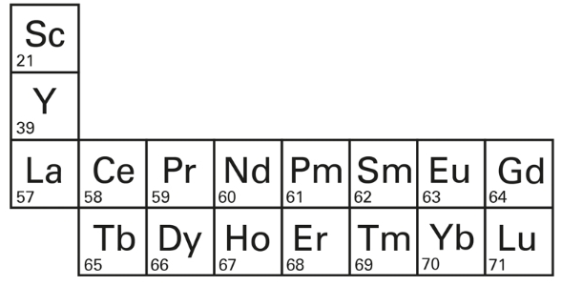

***Figure 1.*** *Representation of the rare-earth elements, taken from [3].   
All captions in italics (Arial 10 pt.), centered below the figure.*

Finally, please name your file by combining the surname of the first author and a meaningful keyword from the abstract title (e.g., “Doe Boldface.docx” for this example) and then upload it as a Word file via the registration website.

**References**

[1] J. Doe, *The Chemistry of* *Lanthanide Compounds*, Publisher, Place of Publication, **2010**.

[2] A. B. Author, C. Coauthor, *Inorg. Chem.* **2021**, *60*, 12441.

[3] Terrae Rarae 32 conference website, *https://www.iac.uni-stuttgart.de/forschung/terrae_rarae.*